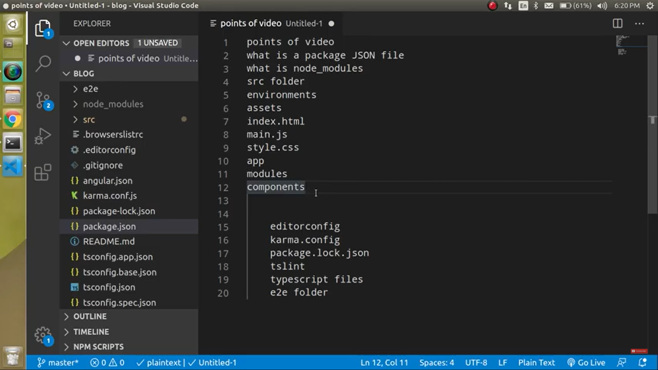

Package.json is the forst file that is cread forst

Polyfills in angular are**few lines of code which make your application compatible for different browsers**. The code we write is mostly in ES6 (New Features: Overview and Comparison) and is not compatible with IE or firefox and needs some environment setups before being able to be viewed or used in these browsers.

Basically **polyfills** compatible for different browsers especially IE old versions **IE8, IE9 and IE10.** Angular has new features which written in **ES6 and typescript**, so polyfills helps to compatible with different browsers.

Angular is written in ES6+ language specification. As many of its features are not supported by all the browsers. So by defining them in polyfill it will be compatible in the given browser.

This file includes polyfills needed by Angular and is loaded before the app. You can add your own extra polyfills to this file.

This file is divided into 2 sections:

1. Browser polyfills. These are applied before loading ZoneJS and are sorted by browsers.
2. Application imports. Files imported after ZoneJS should be loaded before your main file.

[How to use polyfills in Angular application? (iq.js.org)](https://iq.js.org/questions/angular/how-to-use-polyfills-in-angular-application)

